**Assignment 1**

Angad Singh

CS456

apsm4t@umsystem.edu

**Good Design**

A good user interface design should have the following characteristics:

* Simplicity
* Aesthetic
* Usefulness
* Easy to understand
* Error-free
* Leading

**Two examples of good user interface design are:**

1. **Example 1: Slack Mobile App**

Slack is a business communication app which allows easy instant messaging. It's meant for teams and workplaces, can be used across multiple devices and platforms, and is equipped with robust features like persistent chat rooms organized by topic, private groups, and direct messaging.

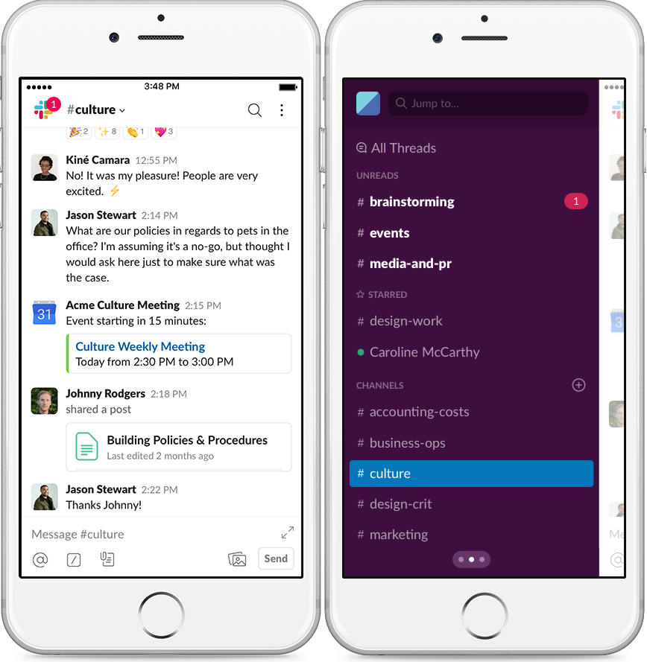

I use this app on a daily basis for communicating with groups for my projects. The particular aspect of this overall interface design that I find good is the side navigation bar.

* + 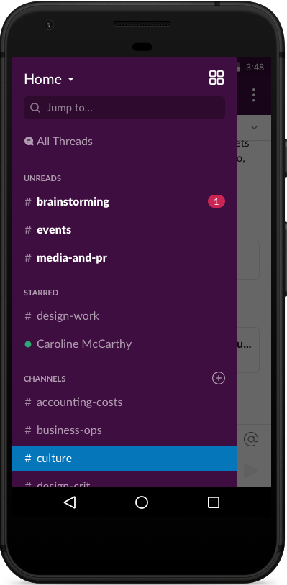Side Navigation Bar

The side navigation bar has a simplistic design which makes it is easy to switch between different channels. The messages are divided into Channels/Private Channels/Direct messages. This makes it easy to view and keep track of all the messages without having them all clustered in one place. The overall user interface design of the side bar looks aesthetic and the fonts are easy to read. I also like how the notifications are displayed with a red circle displaying the number of messages. Overall, this a very good example of a good user interface design and I don’t see any need for further improvements.

1. **Example 2: Car Center Console**